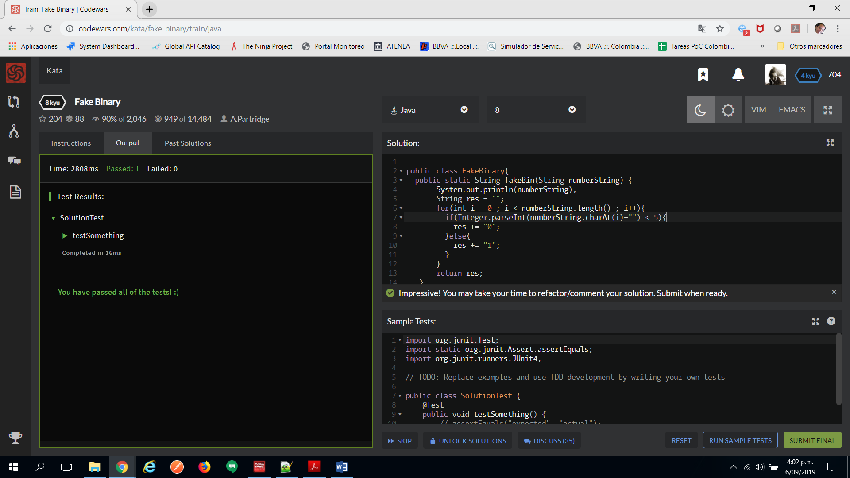

public class FakeBinary{

public static String fakeBin(String numberString) {

System.out.println(numberString);

String res = "";

for(int i = 0 ; i < numberString.length() ; i++){

if(Integer.parseInt(numberString.charAt(i)+"") < 5){

res += "0";

}else{

res += "1";

}

}

return res;

}

}

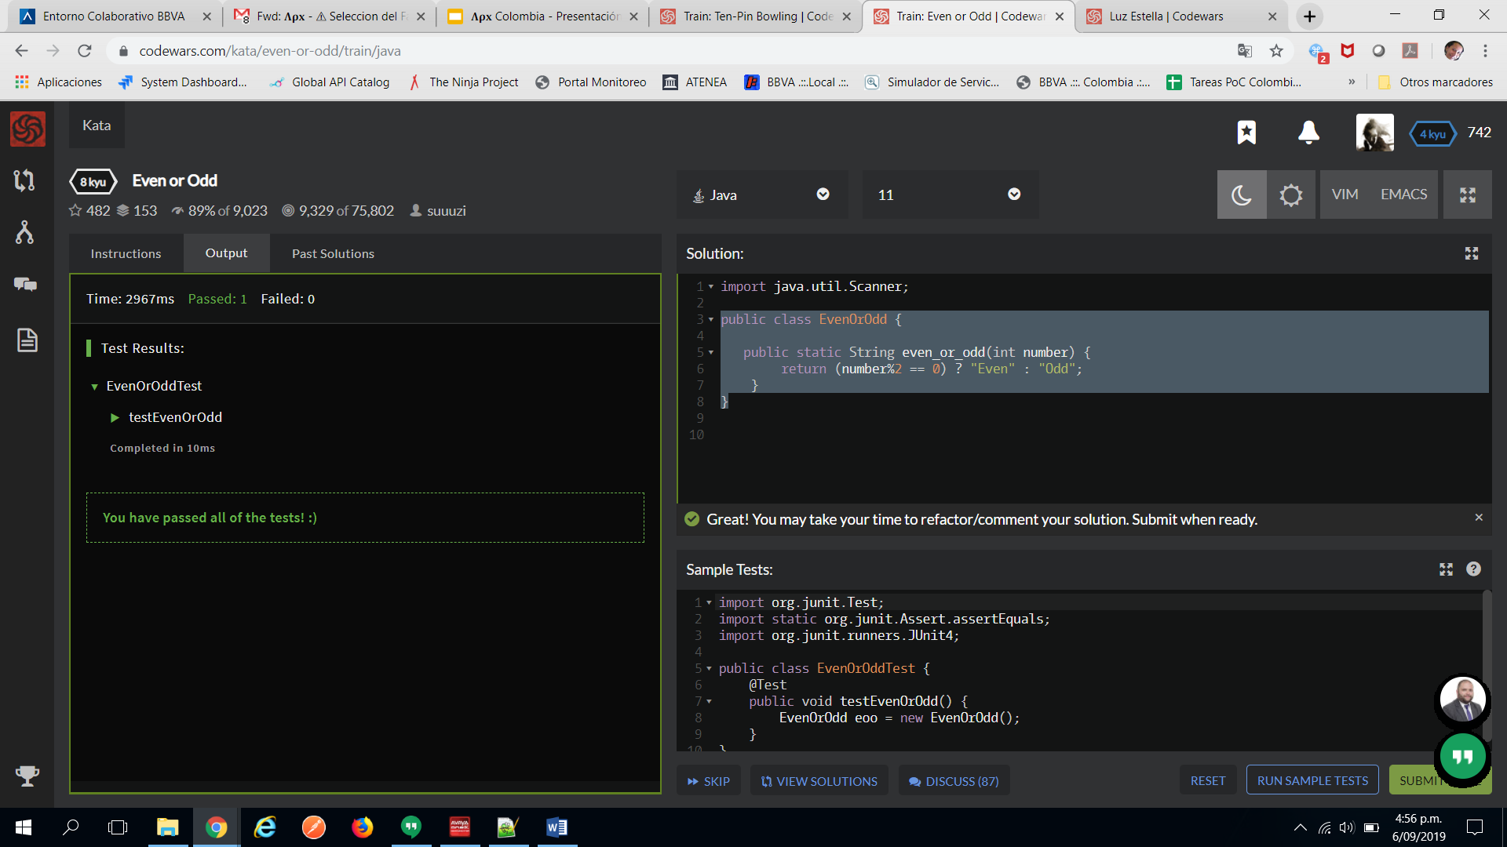

public class EvenOrOdd {

public static String even_or_odd(int number) {

return (number%2 == 0) ? "Even" : "Odd";

}

}

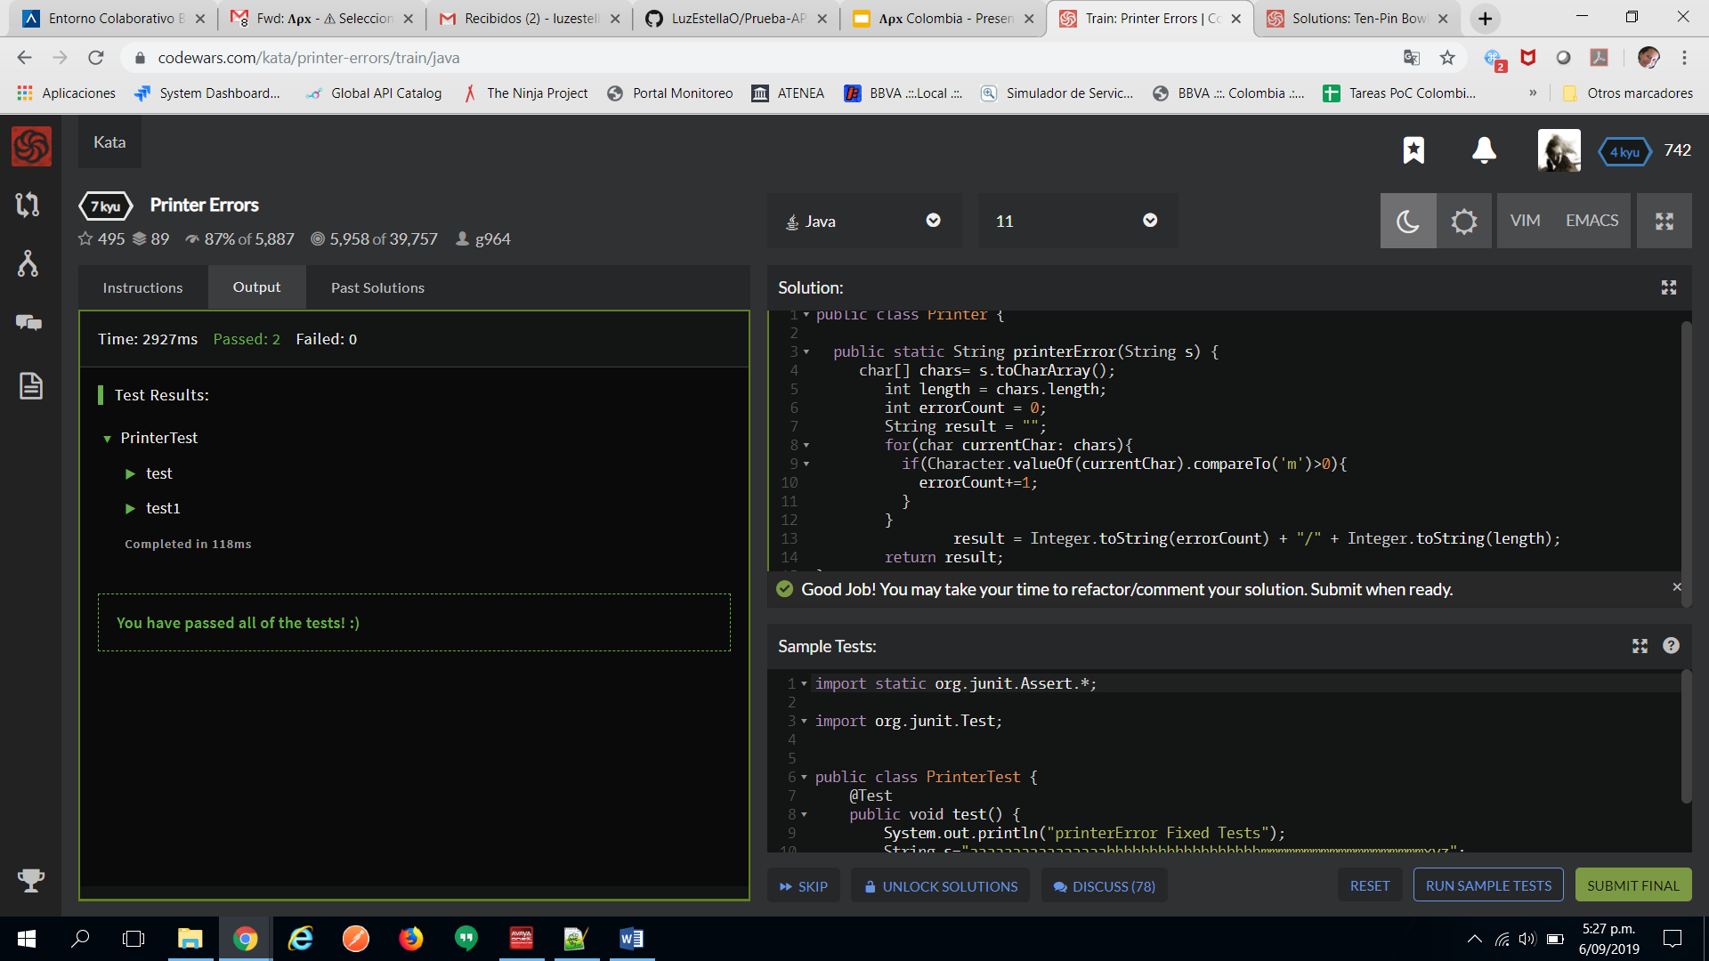

public class Printer {

public static String printerError(String s) {

char[] chars= s.toCharArray();

int length = chars.length;

int errorCount = 0;

String result = "";

for(char currentChar: chars){

if(Character.valueOf(currentChar).compareTo('m')>0){

errorCount+=1;

}

}

result = Integer.toString(errorCount) + "/" + Integer.toString(length);

return result;

}

}

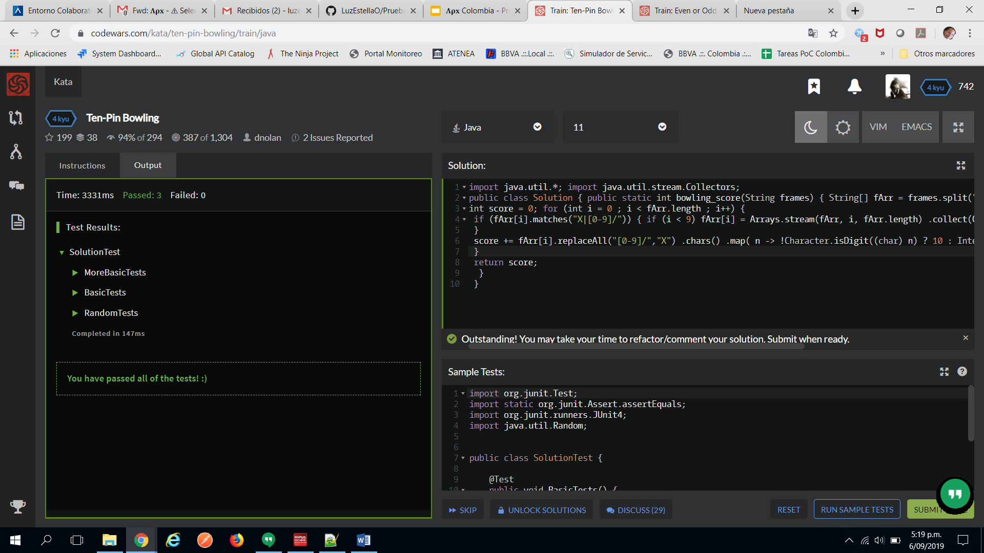

import java.util.*; import java.util.stream.Collectors;

public class Solution {

public static int bowling_score(String frames) { String[] fArr = frames.split(" ");

int score = 0;

for (int i = 0 ; i < fArr.length ; i++) {

if (fArr[i].matches("X|[0-9]/")) {

if (i < 9) fArr[i] = Arrays.stream(fArr, i, fArr.length) .collect(Collectors.joining("")) .substring(0, 3); }

score += fArr[i].replaceAll("[0-9]/","X") .chars() .map( n -> !Character.isDigit((char) n) ? 10 : Integer.valueOf(Character.toString((char) n))) .sum();

}

return score; } }